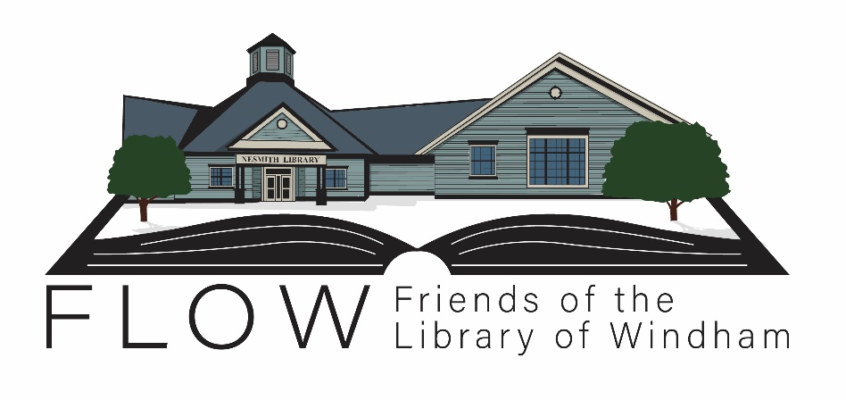

The Friends of the Library of Windham (FLOW) is pleased to announce that it will be awarding three distinct grants for a total amount of $5,500 in 2021; two are for high school seniors working toward a four-year degree at a college or university, and one is for a high school senior going to a community college or trade school.

The recipients of the FLOW 2021 Grants will be awarded funds to use toward tuition, the purchase of books, and any other supplies needed to further their education. This is a one-time award, not an annual recurring one. Recipients may only receive it once. Grant winners will be announced at the Windham High School Scholarship Night.

Applications are available at the Nesmith Library, FLOW’s website, and on the school’s scholarship portal. Please complete all the required steps carefully and return it either to the Windham High School Guidance Office or to the library by the end of day on **Wednesday, April 1, 2021.**

Application Process

* Complete Application form Page 2
* Required essay Page 3
* Description of each grant and its relevant requirements
  + The Mary Long Grant for the Arts ($2,000) Page 4
  + The Professional Studies Grant ($2,000) Page 5
  + The Community College/Trade School Grant ($1,500) Page 6
  + Scoring Rubric for the FLOW grants Page 7
* In addition to the forms, documents, and an essay, the final applicants for each grant may be invited to a personal interview prior to determination of the award.

If you have any questions or concerns, please email Scholarships@FlowWindham.org.

# Friends of the Library of Windham

# Grant 2021

# Application

Please indicate which grant you are applying for:

* The Mary Long Arts Grant

# The Professional Studies Grant

* The Community College/Trade School Grant

Applicant’s Name:

Address:

Email:

Phone Number:

High School: GPA:

College Acceptance:

Intended Major:

If chosen I would like to receive my award:

* at the Windham High School Scholarship Night
* at the high school I attend (not WHS).
* in a more private setting

Essay

Please write a short essay (300-500 words) that describes who you are. The essay can focus on any specific topic you like (such as sports, outside activities, community action, academics, a person who has made a big impact on your life, religion, etc.), but must address the following:

* What is your passion in life?
* How do you plan to get there?
* What have you done in or out of school that addresses your passion?
* How is secondary education going to feed that passion?
* Why do you deserve this grant money?

***Your essay must be typed. Do not submit a handwritten essay.***

The essay will be evaluated on the following: (scoring rubric attached)

* Clarity (how well you have expressed your passion)
* Realistic goals (how attainable your goals appear)
* Quality of writing (good grammar, sensible transitions, spell-checked)
* Coherence (Does your essay make sense? Do your goals and passions comport with your activities and argument for getting the award?)

Requirements for the Mary Long Arts Grant

### The Mary Long Arts Grant is established to help students pursue their studies in the arts. Examples of degrees may include:

|  |  |  |  |
| --- | --- | --- | --- |
| Architecture  Art  Art Conservation  Art History | Broadcast Journalism  Communications  Creative Writing  Dance | Drama/Theatre  Music  Film  Graphic Arts | Web Design  Museum Studies |

**Minimum Requirements for this grant**

* Acceptance to a four-year accredited university or college in one of the above programs
* Windham Resident
* Grade point average of 3.0 or higher
* Graduating Senior

**Required documentation**

Each of these items must accompany the application. If any items are missing, the application will be returned to the student for completion before evaluation.



* Copy of acceptance letter from university or college
* Offical transcript from your high school in a sealed envelope with the school seal
* Three letters of reference
* A non-academic recommendation letter by an employer, coach, minister, or club/activity
* A recommendation made by a supervisor or witness to your community service.
* A letter of recommendation of your choice (not a family member).
* Completed essay

Requirements for Professional Studies Grant

### The Professional Studies Grant is established to help students pursue their professional studies. Examples of eligible disciplines may include, but are not limited to:

|  |  |  |  |
| --- | --- | --- | --- |
| Applied Sciences  Business  Computer Science  Engineering  Education  Health and Human Services | Life Sciences  Physical Sciences  Pre-Law  Pre-Med  Sociology  Psychology |  |  |

**Minimum Requirements for this grant**

* Acceptance to a four-year accredited university or college in one of the programs listed above.
* Windham Resident
* Grade point average of 3.0 or higher
* Graduating Senior

**Required documentation**

Each of these items must accompany the application. If any items are missing, the application will be returned to the student for completion before evaluation.



* Copy of acceptance letter from university or college
* Official transcript from your high school in a sealed envelope with the school seal
* Three letters of reference
* A non-academic recommendation letter by an employer, coach, minister, or club/activity
* A recommendation made by a supervisor or witness to your community service.
* A letter of recommendation of your choice (not a family member).
* Completed essay

Requirements for Community College and Trade School Grant

### The Community College/Trade School Grant is established to help students attend a two-year community college or a vocational school. FLOW recognizes not all students want or need to go to a four-year institution to accomplish their next step in education. A two-year community college offers a variety of educational programs that can lead to earning an associate’s degree or a certification. A vocational school is any educational institution that is specifically geared toward helping students get employment-ready skills and knowledge for particular occupations.

### Examples of schools include, but are not limited to the following. Schools located in other states are acceptable options.

|  |  |  |
| --- | --- | --- |
| Concord Regional Technical Center  Empire Beauty Schools of New Hampshire  Great Bay Community College  Lakes Region Community College  Manchester Community College | Manchester School of Technol  Nashua Community College  Nashua Technical Center  NHTI | NH Real Estate School  River Valley Community College  The New Hampshire School of Mechanical Trades  White Mountains Community College |

**Minimum Requirements for this grant**

* Acceptance in a two-year accredited community college or trade school
* Windham Resident
* Grade point average of 2.5 or higher
* Graduating Senior

**Required documentation**

Each of these items must accompany the application. If any items are missing, the application will be returned to the student for completion before evaluation.



* Copy of acceptance letter to community college or trade school
* Official transcript from your high school in a sealed envelope with the school seal
* Three letters of reference. Please do not use your college application letter as a reference for this grant.
* A non-academic recommendation letter by an employer, coach, minister, or club/activity
* A recommendation made by a supervisor or witness to your community service.
* A letter of recommendation of your choice (not a family member).
* Completed essay

Scoring Rubric for the FLOW Grants:

**Clarity** measures how well the student has expressed his or her passion.

1 = vague (I like sports)  
 2 = poorly expressed (I want to do something with sports)  
 3 = clear (I want to be a major league baseball player)

**Realistic goals** measures the potential for attainability of the expressed goals.

1 = a real stretch (I will walk on the moon)  
2 = a challenge (I will become an astronaut)   
3 = attainable under reasonable circumstances (I will get a job in NASA)

**Quality of writing** is a highly subjective category, difficult to quantify but easy to identify.

1 = many grammatical mistakes that detract from understanding  
2 = some grammatical mistakes/spelling errors  
3 = very few grammatical mistakes/spelling errors

**Coherence** describes how well the goals and passions comport with the activities and argument for getting the award.

1 = incoherent or confusing (I like sports but have not played on any teams.)  
2 = unclear (I want to do something with sports. My outside activities include playing in the band)  
3 = logical (I want to be a major league baseball player. I have been MVP for three years in high school and play on a statewide team in the summer.)